SQL ASSIGNMENT 2

1.Write a query to create a recursive hierarchy showing employees and the managers they report to.
WITH RECURSIVE employee_hierarchy AS (

SELECT
employeeNumber,
CONCAT(firstName, ' ', lastName) AS employee_name,
reportsTo,
1 AS level
FROM employees
WHERE reportsTo IS NULL

UNION ALL

SELECT
e.employeeNumber,
CONCAT(e.firstName, ' ', e.lastName) AS employee_name,
e.reportsTo,
eh.level + 1 AS level
FROM employees e
JOIN employee_hierarchy eh
ON e.reportsTo = eh.employeeNumber
)

SELECT *
FROM employee_hierarchy
ORDER BY level, reportsTo;
Query Explanation :
The anchor query selects top-level managers (reportsTo IS NULL) and assigns them Level 1.
The recursive part joins employees to their managers using e.reportsTo = eh.employeeNumber.
Each recursion increases the level, building the full reporting hierarchy.

Result Explanation :
The output shows each employee along with their manager relationship.
The level column indicates the depth in the hierarchy (1 = top manager).
It forms a structured chain from senior managers down to lower-level employees.

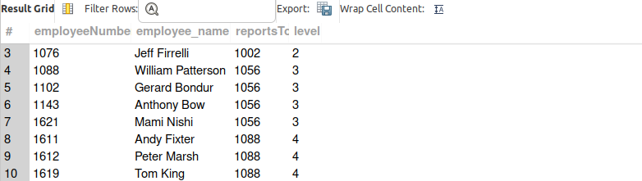

2.Generate a hierarchy showing employee names and their reporting chain up to the CEO.

WITH RECURSIVE employee_chain AS ( employeeNumber,
CONCAT(firstName, ' ', lastName) AS employee_name,
reportsTo,
CONCAT(firstName, ' ', lastName) AS reporting_chain
FROM employees

UNION ALL

SELECT
ec.employeeNumber,
ec.employee_name,
m.reportsTo,
CONCAT(ec.reporting_chain, ' → ',
CONCAT(m.firstName, ' ', m.lastName))
FROM employee_chain ec
JOIN employees m
ON ec.reportsTo = m.employeeNumber
)
SELECT employeeNumber, employee_name, reporting_chain
FROM employee_chain
WHERE reportsTo IS NULL;
Query Explanation :
The anchor query selects every employee and initializes the reporting chain with their own name.
The recursive part joins each employee to their manager using reportsTo and appends the manager’s name to the chain.
The recursion continues upward until it reaches the CEO (where reportsTo is NULL).
Result Explanation :
The output shows each employee along with their complete reporting chain.
The reporting_chain column displays the path from the employee up to the CEO.
Each row represents one employee with their full managerial hierarchy.
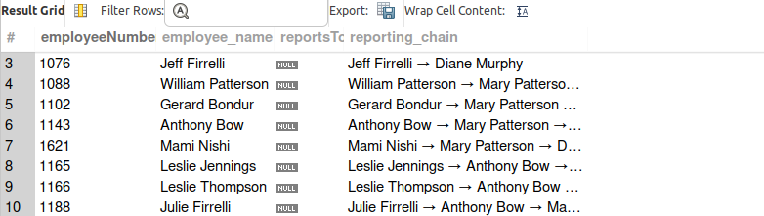
3.For each product line, calculate the rank of products based on their MSRP in descending order.
WITH product_ranking AS (
SELECT
productLine,
productName,
MSRP
FROM products
)
SELECT
productLine,
productName,
MSRP,
RANK() OVER (
PARTITION BY productLine
ORDER BY MSRP DESC
) AS price_rank
FROM product_ranking;
Query Explanation :
The query selects productLine, productName, and MSRP from the products table.
The RANK() window function partitions data by productLine and orders products by MSRP in descending order.
Each product is assigned a rank within its product line based on its price.
Result Explanation :
The output shows products grouped by product line.
The price_rank column indicates the position of each product within its product line based on MSRP.
Higher-priced products receive better ranks (rank 1 = highest MSRP in that product line).
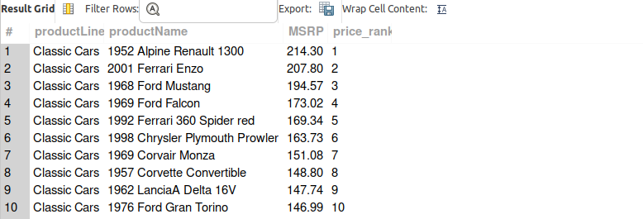

4.Write a query to find the difference in MSRP between a product and the next product in the same product line using LEAD.
WITH product_price_diff AS (
SELECT
productLine,
productName,
MSRP,
LEAD(MSRP) OVER (
PARTITION BY productLine
ORDER BY MSRP DESC
) AS next_product_msrp
FROM products
)
SELECT
productLine,
productName,
MSRP,
next_product_msrp,
MSRP - next_product_msrp AS msrp_difference
FROM product_price_diff;
Query Explanation :
The LEAD() function retrieves the MSRP of the next product within the same product line.
The window is partitioned by productLine and ordered by MSRP in descending order.
The difference is calculated by subtracting the next product’s MSRP from the current product’s MSRP.
Result Explanation :
The output shows each product along with the MSRP of the next product in the same product line.
The msrp_difference column displays the price gap between consecutive products.
The last product in each product line will have NULL as there is no next product.
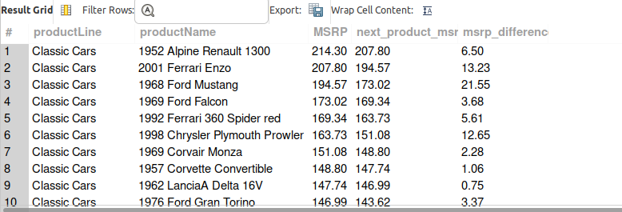

5.Use LAG to calculate the percentage change in quantityInStock between consecutive products in the same product line.
WITH stock_change AS (
SELECT
productLine,
productName,
quantityInStock,
LAG(quantityInStock) OVER (
PARTITION BY productLine
ORDER BY productName
) AS previous_quantity
FROM products
)
SELECT
productLine,
productName,
quantityInStock,
previous_quantity,
ROUND(
(quantityInStock - previous_quantity) * 100.0
/ previous_quantity,
2
) AS percentage_change
FROM stock_change;
Query Explanation :
The LAG() function retrieves the quantityInStock of the previous product within the same product line.
The window is partitioned by productLine and ordered by productName to define consecutive products.
The percentage change is calculated using the formula (Current − Previous) / Previous × 100.
Result Explanation :
The output shows each product along with its previous product’s stock quantity.
The percentage_change column displays how much the stock changed compared to the previous product.
The first product in each product line will have NULL values because there is no previous product.
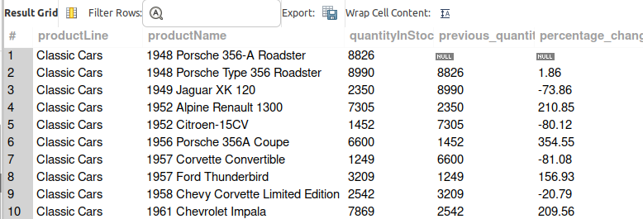

- Segment customers into high-value, medium-value, and low-value tiers based on their creditLimit.

SELECT
customerNumber,
customerName,
creditLimit,
CASE
WHEN creditLimit >= 100000 THEN 'High-Value'
WHEN creditLimit BETWEEN 25000 AND 99999 THEN 'Medium-Value'
ELSE 'Low-Value'
END AS customer_tier
FROM customers;

Query Explanation
The CASE statement is used to classify customers into different tiers.If the creditLimit is greater than or equal to 100000, the customer is labeled High-Value.If the creditLimit is between 25000 and 99999, the customer is labeled Medium-Value.If the creditLimit is less than 25000, the customer is labeled Low-Value.

Result Explanation
The result shows each customer along with their credit limit and the value tier they belong to.
The customer_tier column indicates whether the customer is High-Value, Medium-Value, or Low-Value based on their credit limit.
This segmentation helps businesses identify important customers and tailor marketing or financial strategies accordingly.
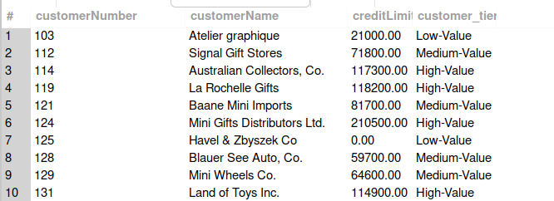

7.Group products into segments based on their MSRP range (e.g., low, medium, high).
SELECT
productCode,
productName,
productLine,
MSRP,
CASE
WHEN MSRP < 50 THEN 'Low Price Segment'
WHEN MSRP BETWEEN 50 AND 100 THEN 'Medium Price Segment'
ELSE 'High Price Segment'
END AS price_segment
FROM products;

Query Explanation

The CASE statement is used to categorize products based on their MSRP value.
If the MSRP is less than 50, the product is classified as Low Price Segment.
If the MSRP is between 50 and 100, the product is classified as Medium Price Segment.
If the MSRP is greater than 100, the product is classified as High Price Segment.

Result Explanation

The result displays each product along with its MSRP and the price segment it belongs to.
The price_segment column shows whether a product falls under Low, Medium, or High price category.
This segmentation helps businesses analyze product pricing strategies and understand how products are distributed across different price ranges.
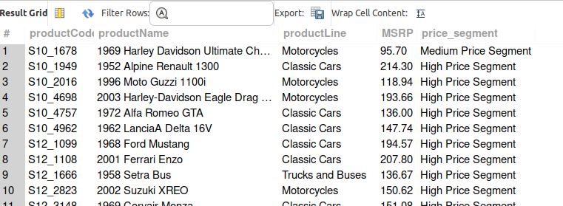

8.Find the top 3 customers with the highest total payment amounts.
SELECT
c.customerNumber,
c.customerName,
SUM(p.amount) AS total_payment
FROM customers c
JOIN payments p
ON c.customerNumber = p.customerNumber
GROUP BY c.customerNumber, c.customerName
ORDER BY total_payment DESC
LIMIT 3;

Query Explanation

The JOIN operation connects the customers table with the payments table using customerNumber.
The SUM() function calculates the total payment amount made by each customer.
The GROUP BY clause groups the records by customerNumber and customerName so that the total payments can be calculated for each customer.
The ORDER BY clause sorts the results in descending order of total payment amounts.
The LIMIT 3 clause ensures that only the top three customers with the highest total payments are returned.

Result Explanation
The output shows the customer number, customer name, and their total payment amount.
Customers are sorted from highest to lowest total payment.
Only the top 3 customers with the largest total payments are displayed in the result.
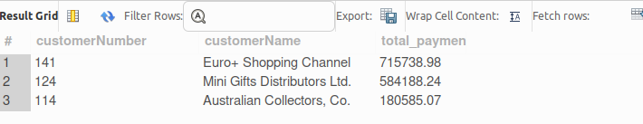

9.Calculate the total revenue generated for each productLine and identify the product line contributing the most revenue.
SELECT
p.productLine,
SUM(od.quantityOrdered * od.priceEach) AS total_revenue
FROM products p
JOIN orderdetails od
ON p.productCode = od.productCode
GROUP BY p.productLine
ORDER BY total_revenue DESC;

Query Explanation
The JOIN operation connects the products table with the orderdetails table using productCode.
The revenue for each order item is calculated using the formula:
quantityOrdered × priceEach.
The SUM() function calculates the total revenue generated by each product line.
The GROUP BY clause groups the results by productLine so that revenue can be aggregated for each category.
The ORDER BY total_revenue DESC sorts the product lines from highest revenue to lowest revenue.

Result Explanation
The output displays each product line along with the total revenue generated from all its products.
The product lines are sorted in descending order of revenue, making it easy to identify the product line contributing the most revenue, which will appear at the top of the result.
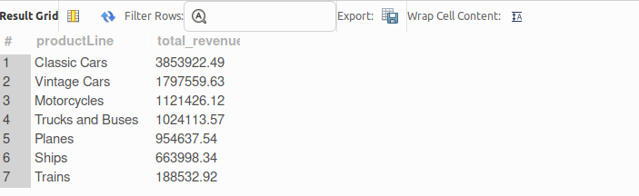

10.Identify customers who placed more than one order within the same day.
SELECT
c.customerNumber,
c.customerName,
o.orderDate,
COUNT(o.orderNumber) AS total_orders
FROM customers c
JOIN orders o
ON c.customerNumber = o.customerNumber
GROUP BY c.customerNumber, c.customerName, o.orderDate
HAVING COUNT(o.orderNumber) > 1;

Query Explanation
The JOIN operation connects the customers table with the orders table using customerNumber.
The COUNT() function calculates the number of orders placed by each customer on a particular date.
The GROUP BY clause groups the records by customerNumber, customerName, and orderDate so that orders placed by the same customer on the same day are grouped together.
The HAVING clause filters the grouped results to return only those records where the number of orders is greater than 1.

Result Explanation
The result shows customers who placed multiple orders on the same day.
The output includes the customer number, customer name, order date, and the total number of orders placed on that day.
Only customers with more than one order on the same date appear in the result.
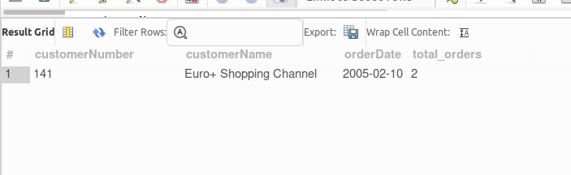

11.Find the most common product scale (productScale) ordered by customers in each region (territory).
WITH scale_counts AS (
SELECT
o.territory,
p.productScale,
COUNT(*) AS total_orders
FROM customers c
JOIN orders ord
ON c.customerNumber = ord.customerNumber
JOIN orderdetails od
ON ord.orderNumber = od.orderNumber
JOIN products p
ON od.productCode = p.productCode
JOIN employees e
ON c.salesRepEmployeeNumber = e.employeeNumber
JOIN offices o
ON e.officeCode = o.officeCode
GROUP BY o.territory, p.productScale
),
ranked_scales AS (
SELECT
territory,
productScale,
total_orders,
RANK() OVER (PARTITION BY territory ORDER BY total_orders DESC) AS rnk
FROM scale_counts
)
SELECT
territory,
productScale,
total_orders
FROM ranked_scales
WHERE rnk = 1;

Query Explanation
The first CTE (scale_counts) calculates how many times each productScale was ordered in every territory.
This is done by joining the customers, orders, orderdetails, products, employees, and offices tables to connect customers to their respective regions.
The COUNT() function counts the number of orders for each product scale within each territory.
The second CTE (ranked_scales) ranks product scales within each territory based on the number of orders using the RANK() window function.
The ranking is partitioned by territory and ordered by total orders in descending order.

Result Explanation
The result shows the most frequently ordered product scale in each territory.
The output includes the territory, product scale, and the number of orders for that scale.
Only the top-ranked product scale in each territory appears in the result, representing the most common product scale ordered by customers in that region.
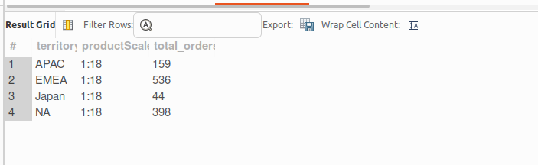

12.Write a query to find customers who have never made a payment.
SELECT
customerNumber,
customerName
FROM customers
WHERE customerNumber NOT IN (
SELECT customerNumber
FROM payments
);

Query Explanation
The subquery retrieves all customerNumber values from the payments table, representing customers who have made payments.
The NOT IN condition filters the customers table to return only those customers whose customerNumber does not appear in the payments table.
This ensures that only customers who have never made any payment are selected.

Result Explanation
The result displays the customer number and customer name of customers who do not have any payment records.
These customers are identified because their customerNumber is absent from the payments table.
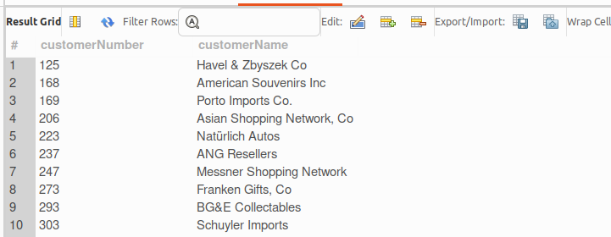
13.Identify orders where the total priceEach exceeds the customer's creditLimit.
WITH order_totals AS (
SELECT
o.orderNumber,
o.customerNumber,
SUM(od.quantityOrdered * od.priceEach) AS total_order_amount
FROM orders o
JOIN orderdetails od
ON o.orderNumber = od.orderNumber
GROUP BY o.orderNumber, o.customerNumber
)
SELECT
c.customerNumber,
c.customerName,
ot.orderNumber,
ot.total_order_amount,
c.creditLimit
FROM order_totals ot
JOIN customers c
ON ot.customerNumber = c.customerNumber
WHERE ot.total_order_amount > c.creditLimit;

Query Explanation
The CTE (order_totals) calculates the total value of each order by multiplying quantityOrdered with priceEach and summing the results for each order.
The SUM(quantityOrdered × priceEach) formula represents the total amount of the order.
The orders table is joined with orderdetails to calculate this value for each order.
After calculating order totals, the result is joined with the customers table using customerNumber.
The WHERE clause filters the results to show only those orders where the total order amount exceeds the customer's credit limit.

Result Explanation
The output shows the customer number, customer name, order number, total order amount, and credit limit.
Only orders where the total order value is greater than the customer's credit limit appear in the result.
This helps identify orders that exceed the allowed credit limit for a customer.
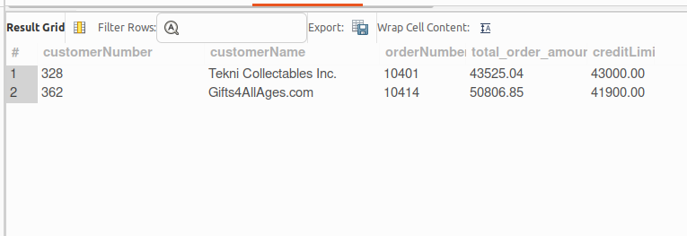
14.Calculate the number of days between the orderDate and shippedDate for each order.
SELECT
orderNumber,
orderDate,
shippedDate,
DATEDIFF(shippedDate, orderDate) AS days_to_ship
FROM orders;

Query Explanation
The DATEDIFF() function calculates the difference in days between two dates.
In this query, DATEDIFF(shippedDate, orderDate) computes the number of days it took to ship each order.
The query selects the order number, order date, shipped date, and the calculated difference in days.

Result Explanation
The output shows each order along with its order date and shipped date.
The days_to_ship column represents the number of days taken to ship the order.
If the shippedDate is NULL, the result will also show NULL for the shipping days because the order has not yet been shipped.
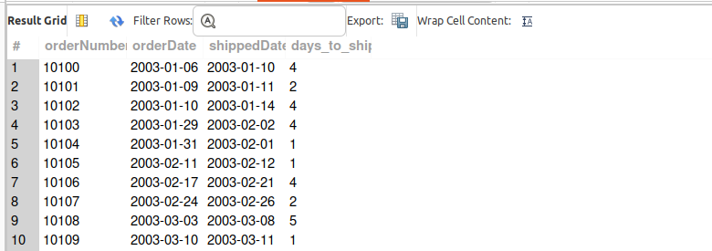
15.Find orders that were shipped late (i.e., after the requiredDate).
SELECT
orderNumber,
orderDate,
requiredDate,
shippedDate
FROM orders
WHERE shippedDate > requiredDate;

Query Explanation
The query selects order details from the orders table.
The WHERE clause compares shippedDate with requiredDate.
If the shippedDate is greater than the requiredDate, it means the order was shipped later than the required delivery date.
Only such records are returned in the result.

Result Explanation
The result shows order number, order date, required date, and shipped date for orders that were shipped late.
These are the orders where the shipping date exceeded the required delivery date, indicating a delay in shipment.
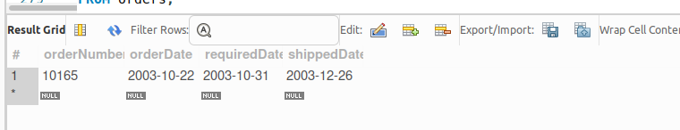
16.Create a recursive query to calculate the cumulative sales amount for each product line, considering all orders placed.
WITH RECURSIVE sales_data AS (
SELECT
p.productLine,
od.orderNumber,
(od.quantityOrdered * od.priceEach) AS sales_amount
FROM products p
JOIN orderdetails od
ON p.productCode = od.productCode
),
cumulative_sales AS (
SELECT
productLine,
orderNumber,
sales_amount,
sales_amount AS cumulative_amount
FROM sales_data
WHERE orderNumber = (SELECT MIN(orderNumber) FROM sales_data)
UNION ALL
SELECT
s.productLine,
s.orderNumber,
s.sales_amount,
cs.cumulative_amount + s.sales_amount
FROM sales_data s
JOIN cumulative_sales cs
ON s.productLine = cs.productLine
AND s.orderNumber > cs.orderNumber
)
SELECT
productLine,
SUM(sales_amount) AS total_sales
FROM sales_data
GROUP BY productLine;

Query Explanation
The first CTE (sales_data) calculates the sales amount for each order item using the formula quantityOrdered × priceEach.
This is done by joining the products table with the orderdetails table using productCode.
The second recursive CTE (cumulative_sales) starts with the first order as the base case and then recursively adds the sales amount of subsequent orders to compute cumulative totals.
The final query aggregates the results to calculate the total sales generated by each product line.

Result Explanation
The output displays each product line along with the total sales amount generated from all orders.
The cumulative calculation ensures that sales from multiple orders are progressively aggregated, providing insight into the overall contribution of each product line to total revenue.
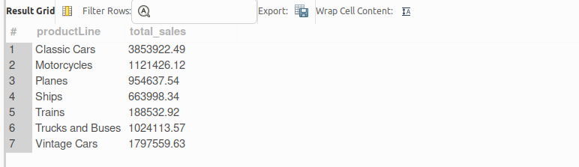

17.Find employees whose sales (amount) are below the average sales in their territory.
WITH employee_sales AS (
SELECT
e.employeeNumber,
CONCAT(e.firstName, ' ', e.lastName) AS employee_name,
o.territory,
SUM(p.amount) AS total_sales
FROM employees e
JOIN customers c
ON e.employeeNumber = c.salesRepEmployeeNumber
JOIN payments p
ON c.customerNumber = p.customerNumber
JOIN offices o
ON e.officeCode = o.officeCode
GROUP BY e.employeeNumber, employee_name, o.territory
),
territory_avg AS (
SELECT
territory,
AVG(total_sales) AS avg_sales
FROM employee_sales
GROUP BY territory
)
SELECT
es.employeeNumber,
es.employee_name,
es.territory,
es.total_sales
FROM employee_sales es
JOIN territory_avg ta
ON es.territory = ta.territory
WHERE es.total_sales < ta.avg_sales;

Query Explanation
The first CTE (employee_sales) calculates the total sales made by each employee by summing the amount from the payments table.
This is done by joining the employees, customers, payments, and offices tables to associate employees with their customers and territories.
The second CTE (territory_avg) calculates the average sales for each territory using the totals obtained in the first CTE.
Finally, the main query joins these results and filters employees whose total sales are less than the average sales in their respective territory.

Result Explanation
The output shows the employee number, employee name, territory, and their total sales.
Only employees whose sales are below the average sales of their territory appear in the result.
This helps identify employees who may be underperforming compared to others in the same region.
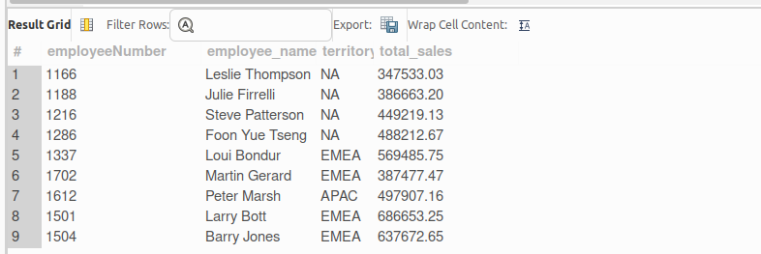

18.Determine the number of orders placed each week for the past year.
SELECT
YEAR(orderDate) AS order_year,
WEEK(orderDate) AS order_week,
COUNT(orderNumber) AS total_orders
FROM orders
WHERE orderDate >= DATE_SUB(CURDATE(), INTERVAL 1 YEAR)
GROUP BY YEAR(orderDate), WEEK(orderDate)
ORDER BY order_year, order_week;

Query Explanation
The YEAR() function extracts the year from the orderDate, while the WEEK() function extracts the week number.
The COUNT() function counts the number of orders placed in each week.
The WHERE clause filters orders from the past one year using DATE_SUB(CURDATE(), INTERVAL 1 YEAR).
The GROUP BY clause groups the orders by year and week number to calculate weekly totals.
The ORDER BY clause sorts the results chronologically.
Result Explanation
The output shows the year, week number, and total number of orders placed in each week.
Only orders from the last 12 months are included in the result.
This helps analyze weekly ordering trends over the past year.

19.Write a query to find the longest chain of product orders (linked by orderNumber) where all orders were placed within a week.
WITH RECURSIVE order_chain AS (
SELECT
orderNumber,
orderDate,
orderNumber AS start_order,
1 AS chain_length
FROM orders
UNION ALL
SELECT
o.orderNumber,
o.orderDate,
oc.start_order,
oc.chain_length + 1
FROM orders o
JOIN order_chain oc
ON o.orderNumber = oc.orderNumber + 1
AND o.orderDate BETWEEN oc.orderDate AND DATE_ADD(oc.orderDate, INTERVAL 7 DAY)
)
SELECT
start_order,
MAX(chain_length) AS longest_chain
FROM order_chain
GROUP BY start_order
ORDER BY longest_chain DESC
LIMIT 1;

Query Explanation
The recursive CTE (order_chain) is used to build sequences of orders.
The base query selects each order as a starting point and initializes the chain_length as 1.
The recursive part joins the next order where the orderNumber is consecutive (orderNumber + 1).
It also ensures that the next order’s orderDate falls within 7 days of the previous order using DATE_ADD().Each recursive step extends the chain and increments the chain_length.

Result Explanation
The result shows the starting order number and the length of the longest chain of orders where all orders were placed within one week of each other.
The chain represents a continuous sequence of order numbers satisfying the time constraint.
Only the longest chain is returned in the final result.
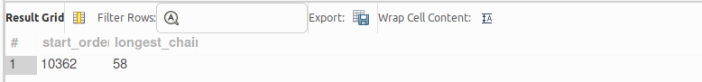

20.Find customers whose total payments exceed the average payment for all customers.
WITH customer_payments AS (
SELECT
customerNumber,
SUM(amount) AS total_payment
FROM payments
GROUP BY customerNumber
),
avg_payment AS (
SELECT
AVG(total_payment) AS avg_total_payment
FROM customer_payments
)
SELECT
c.customerNumber,
c.customerName,
cp.total_payment
FROM customer_payments cp
JOIN customers c
ON cp.customerNumber = c.customerNumber
JOIN avg_payment ap
ON cp.total_payment > ap.avg_total_payment;

Query Explanation
The first CTE (customer_payments) calculates the total payment made by each customer using the SUM(amount) function grouped by customerNumber.
The second CTE (avg_payment) calculates the average of the total payments across all customers.
The final query joins the customers table with the calculated totals and filters the results to return only customers whose total payment is greater than the overall average payment.

Result Explanation
The result displays the customer number, customer name, and their total payment amount.
Only customers whose total payments exceed the average total payment of all customers are included in the output.
This helps identify high-value customers who contribute more revenue compared to the average customer.
